Ads Creatives and Cases: Policy Enforcement Workflows
Oct 10, 2026 · @sw

How creative review works end to end
Almost every ad is decided by the risk engine, and people decide what the engine cannot. The customer reports that more than 99% of creatives are auto-labeled, so the human queue is mostly edge cases: ads that touch several policies at once, new abuse tactics, region-specific rules, and rich media where meaning sits in the mix of image, audio, text and landing page.
Two human workflows sit behind the engine. Creatives is review of ads the engine cannot label with confidence. Cases is Tier 2 escalation, where advertisers file tickets asking why an ad was taken down and reviewers re-examine the ad, confirm or reverse the call, and tell the advertiser what is missing.
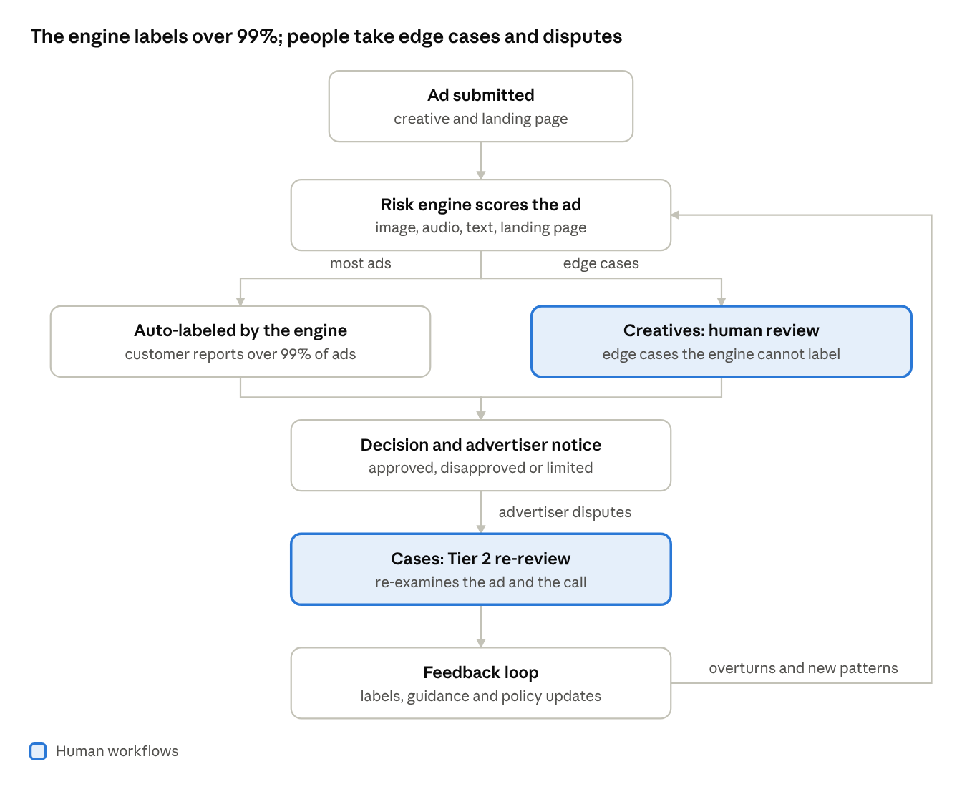
creative review flow · 7 steps, 1 split
Most ads take the left path; edge cases go to Creatives review, and a disputed decision becomes a case whose outcomes feed back to the engine.

Policy enforcement sub-workflows
Each policy area is its own sub-workflow, with its own certification checks, country rules and escalation paths. Google's policy center lists 30 policy areas; the table covers the ones the customer named plus the ones where judgment is hardest.
Policy area | What the reviewer decides | Illustrative edge cases
Gambling and games | Is the advertiser certified for this country and this exact URL? Does the ad or landing page target minors or omit responsible-gambling information? Is it gambling, a non-casino game, or a social casino game? | A "free-to-play" casino app with real-money cues; an affiliate page linking to an unlicensed operator; a certified domain that redirects to an uncertified one
Alcohol | Is it a sale ad, an informational ad, or irresponsible advertising? Does every targeted location allow it? Is the alcohol by volume shown where required? | A non-alcoholic drink carrying a spirits brand; a cocktail video implying social or sexual success; one campaign targeting both allowed and restricted countries
Recreational drugs and other dangerous products | Does the product induce a high, facilitate drug use, or work as a weapon, explosive or tobacco product? Does the narrow CBD exception apply? | A hemp CBD topical aimed outside California, Colorado or Puerto Rico; a "legal high" lookalike; pill-press parts described as kitchen tools
Healthcare and medicines | Is the advertiser a pharmacy, telemedicine provider or manufacturer that needs certification? Are prescription drug terms or unapproved substances involved? | A telehealth video that names a prescription drug only in the voiceover; a supplement said to "work like" a prescription drug; an addiction-treatment ad without the required certification
Misrepresentation | Is anyone impersonated? Is the full price hidden, the claim improbable, the button fake, or the media manipulated? | An AI-generated celebrity endorsement; a free trial whose recurring charge appears only in small print; an ad styled as a system alert
Other areas | Counterfeit goods, trademarks, copyrights, political content, sexual content, financial and crypto products, and protections for children and teens each carry their own tests | An ad that crosses two areas at once, such as a crypto promotion using a political figure's likeness
Four tests repeat across almost every area:
- Who is advertising: the certification, license or verification held, and whether it matches the URL being promoted.
- Where it runs: country, state and age targeting. A mixed campaign comes back "Eligible (limited)"; an all-restricted one is "Disapproved".
- What the creative implies: claims, endorsements and cues across image, audio, text and landing page.
- How severe: unauthorized pharmacies, impersonation and social casino breaches are egregious and lead to suspension without prior warning. Dangerous-products violations carry at least seven days' warning before suspension.

Cases: Tier 2 escalations
A case starts when an advertiser disputes a decision, usually by asking why an ad was taken down. Tier 2 reviewers re-examine the ad, decide whether the original call was right, and tell the advertiser what is missing or what to change.
- Read the ticket and pull the ad, landing page, targeting, account history and the decision that was applied.
- Re-review the ad independently, without leaning on the earlier label.
- Classify the root cause using the table below.
- Choose the outcome: uphold, overturn, or uphold with guidance.
- Reply in plain language, cite the policy and name the exact fix.
- Log the outcome, and send overturns and new patterns back to the risk engine and the policy team.
Root cause | What it looks like | Outcome
Engine false positive | The ad meets policy, such as a non-alcoholic drink flagged as alcohol | Overturn; log as a labeling error
Fixable gap | Missing certification or license; URL does not match the certificate; missing responsible-gambling or alcohol-by-volume information; wrong country or age targeting | Uphold, and tell the advertiser exactly what is missing
True violation | Prescription drugs offered without a prescription; impersonation; manipulated media | Uphold; escalate to account-level review where policy calls for it
Policy ambiguity | The written rules do not clearly cover the ad, such as a new AI-generated format | Escalate to the policy team for a ruling, then add to guidance
Account-level issue | Repeated or circumventing behavior across many ads | Hand to account enforcement
A good reply separates what is missing from what is not. "The ad is fine; your certificate covers a different URL" closes a case. "This violates policy" reopens it. Google's help pages tell advertisers that most edited ads are reviewed within one business day, so case turnaround targets should be set against that expectation.

Operating model and quality
We recommend small specialist pods over a large generalist pool, because volume is low and each decision carries weight.
- Pods by policy cluster: restricted goods (gambling, alcohol, drugs), healthcare and finance, and deception and brand safety. Reviewers build deep policy memory in one cluster.
- Roles: creatives reviewers (Tier 1), case analysts (Tier 2), a policy specialist per cluster, QA calibrators, and a trainer who turns each new edge case into guidance.
- Calibration: weekly sessions against a gold set, with a second review on every overturned or contested decision.
- Wellbeing: rotate reviewers off graphic or adult material and cap exposure.
Metric | Why it matters
Decision accuracy against a gold set | Measures reviewers independently of the engine
Case overturn rate | Points to engine false positives and unclear guidance
Advertiser re-appeal rate | Shows whether replies made clear what is missing
Turnaround time by queue | Keeps advertisers unblocked; compare with Google's one-business-day ad review
Edge cases converted to guidance or labels | Shrinks the edge-case queue over time
Every overturn and every new pattern should leave the pod as a labeled example, a guidance note or a policy question. That is how the human queue stays small as creatives get more complex.

Sources
Policy details come from Google's help pages opened on Oct 10, 2026. The 99% auto-label figure is customer-reported.
- Gambling and games
- Alcohol
- Healthcare and medicines
- Dangerous products or services
- Misrepresentation
- Review process

